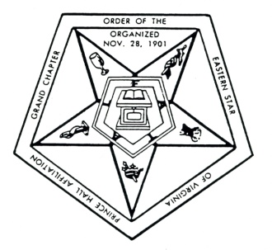
Grand Chapter

Order of Eastern Star of Virginia

Prince Hall Affiliation

DISTRICT DISPENSATION REQUEST

DATE___________________

From: District Council President ____________________________________District No. _____

To: Grand Deputy Organizer ______________________________________________________

A dispensation is requested for the following reason.

Please explain: _________________________________________________________________ _____________________________________________________________________________
_____________________________________________________________________________
_____________________________________________________________________________
_____________________________________________________________________________
_____________________________________________________________________________

_______________________________ ____________________________
(Council President’s Signature) (Council Secretary’s Signature)

All requests for dispensations must be sent to the office of G.D.D.O. and received in a minimum of fifteen (15) days prior to the event accompanied by a self-addressed envelope.

From: Grand District Deputy Organizer ___________________________

To: Grand Worthy Matron: _____________________________

The above request is forwarded to you for your decision.

Date: _______________________ Signature _________________________________

Grand Worthy Matron Approved ___________ Disapproved ___________

Date: _______________________ Signature _________________________________

